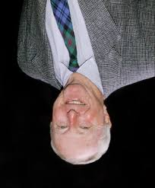
Max Carter AO attended Braund Rd School (now Prospect Primary School) from 1932 – 1938. He later attended Prince Alfred College and Adelaide University where he graduated with a Bachelor of Science. He first worked at the E & W.S Department water laboratories. In 1951 he entered his father’s business of Austral Steel Ltd, Steel Merchants. He worked there until 1961. He continued on the Board until the company was sold in 1971.
In 1966, he began collecting antique porcelain and paintings whilst visiting Europe, Japan, India, China and England. In 1981, Mr Carter was a founding member of the Board of the SA Art Gallery. In 1985, he received an AO (Officer of the Order of Australia) for benefaction to an organisation. He has donated to the South Australian Art Gallery 550 objects to the value of over 23 million dollars.

“Few donors are able to change the shape of a public collection in a dramatic manner, but over forty years, Max Carter has done just that, utterly transforming the Art Gallery of South Australia’s holdings of colonial art” said Director, Christopher Menz. “The combined quality, size and value of this gift is unprecedented in the history of our Australian collection and is further testament to Max’s enormous generosity and philanthropic spirit” he said. Media Release August 2006

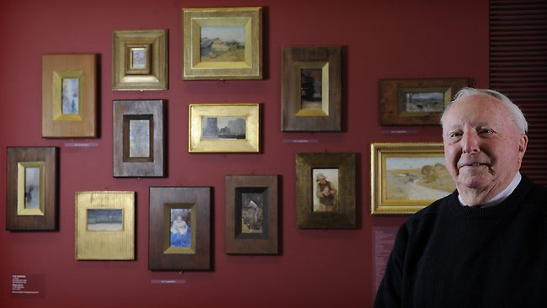
“Never did I think that I would have a collection desirable to the Gallery. I have simply acquired each work because I loved it, much like a family loves every one of their children and it gives me great pleasure to be able to gift them not only to the Gallery but to the people of South Australia,” said Mr Carter. Media Release August 2012

